**Department of Veterans Affairs**

Benefits Integration Platform

VA.gov Education

STEM Form 22-1995 User Guide

Build 4

**Task Order 0005, Benefits Integration Platform**

T4NG Prime Contract No: VA118-16-D-1007

PWS 5.2.5.3.e

Version 2.0

March 2020

| Submitted to: | Submitted by: |
| --- | --- |
| Doris Lin - Department of Veterans Affairs | Booz Allen Hamilton Inc. |
| OIT EPMD Benefits and Memorials (BAM) | 2387 Clements Ferry Road |
| MeiChih.Lin@va.gov | Charleston, SC 29492 |
| (703) 623-4488 | (843) 471-1231 |
|  |  |

Revision History

| **Date** | **Version** | **Description** | **Author** |
| --- | --- | --- | --- |
| 03/13/2020 | 2.0 | Build 4: Updated Section 1.1 to include Build 4 scope; updated Section 2.1 for Build 4 changes. | Booz Allen Hamilton |
| 08/02/2019 | 1.0 | Document creation; delivered for STEM Form 22-1995 implementation. | Booz Allen Hamilton |

Contents

1 Introduction 4

1.1 Scope 4

1.2 Audience 4

2 Using the Software 4

2.1 STEM Form 22-1995 Implementation 4

Figure 1: Find Your Education Benefits Form 5

Figure 2: Manage Your Education Benefits Page 6

Figure 3: Applicant Information Page 6

Figure 4: Education Benefit Page – Select Benefit 7

Figure 5: Education Benefit Page – Rogers STEM Scholarship 7

Figure 6: Education Benefit Page – Additional STEM Questions 8

Figure 7: Education Benefit Page – Additional STEM Questions – Continued 8

Figure 8: Education Benefit Page –Rogers STEM Scholarship Eligibility 9

Figure 9: Military History Page 9

Figure 10: School Selection Page – Want to Attend 10

Figure 11: School Selection Page – Last Attended 11

Figure 12: Personal Information Page – Contact Information 12

Figure 13: Personal Information Page – Direct Deposit Options 13

Figure 14: Personal Information Page – Start or Update Direct Deposit 13

Figure 15: Review Application Page 14

Figure 16: Claim Received Page 15

# Introduction

Veterans enrolled in qualifying Science, Technology, Engineering and Math (STEM) programs can use VA.gov to apply online for the Edith Nourse Rogers STEM Scholarship. Through this scholarship, VA will provide up to nine months of additional Post-9/11 GI Bill benefits to certain eligible individuals.

## Scope

This User Guide describes the STEM integration developed by the VA.gov Education team.

**STEM Form 22-1995 Build 1**

The VA.gov online Request for Change of Program or Place of Training (VA Form 22-1995) has been enhanced to allow users to apply for the Edith Nourse Rogers STEM Scholarship for the following requirements:

* 17511: STEM: Form 22-1995 Integration Phase I

See the VA GitHub vets.gov-team repository for more details:

(<https://github.com/department-of-veterans-affairs/vets.gov-team/issues>)

**STEM Form 22-1995 Build 4**

The STEM Form 22-1995 has been modified for the following requirements:

* 4286: STEM: Wizard and OMB Form Enhancements

See the VA GitHub va.gov-team repository for more details:

(<https://github.com/department-of-veterans-affairs/va.gov-team/issues>)

## Audience

This document targets users and administrators of VA.gov.

# Using the Software

The following subsection provides detailed steps for using VA.gov functionality implemented by the VA.gov Education team.

## STEM Form 22-1995 Implementation

From the second Education Benefit page, shown in Figure 5, if users select **No** for “Are you applying for the Rogers STEM Scholarship?” and then select the **Continue** button, they will be routed through the non-STEM version of the online Form 22-1995. The following steps describe the STEM version of the online form workflow.

1. From the Education and Training | How to Apply for the GI Bill and Other Education Benefits page, in the **How do I apply** section, select the **Find Your Education Benefits Form** menu.
2. Select **Updating my program of study or place of training** or **Applying to extend my Post-9/11 or Fry Scholarship benefits using the Edith Nourse Rogers STEM Scholarship** for “Are you applying for a benefit or updating your program or place of training?” as shown in Figure 1.

Figure 1: Find Your Education Benefits Form

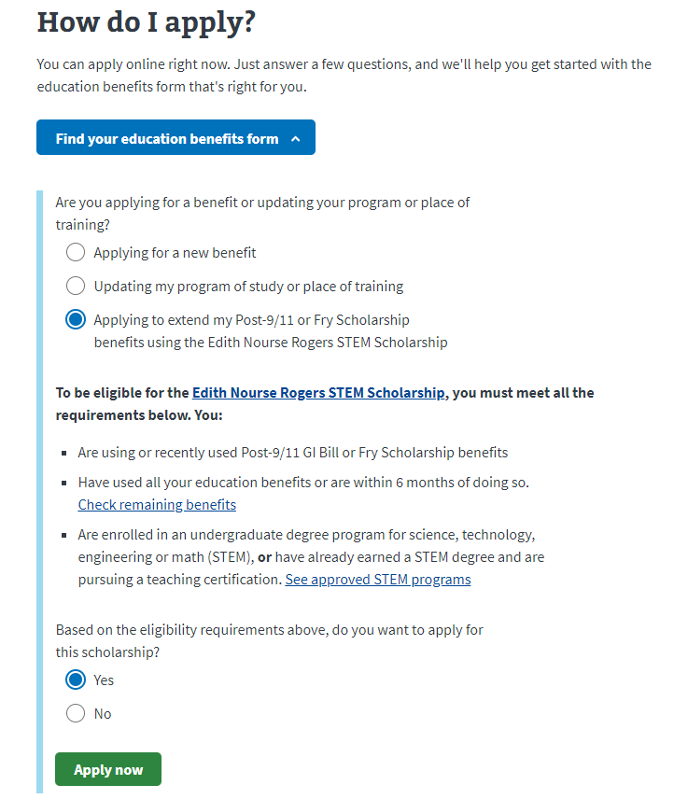

1. If you select **Updating my program of study or place of training**, select a response to “Are you receiving education benefits transferred to you by a sponsor Veteran?”
2. If you select **Applying to extend my Post-9/11 or Fry Scholarship benefits using the Edith Nourse Rogers STEM Scholarship**, review the eligibility information and select **Yes** for “Based on the eligibility requirements above, do you want to apply for this scholarship?”
3. Select the **Apply Now** button.
4. If you are not signed in to your VA account, you will be prompted to sign in. You can sign in or select the **Start your application without signing in** link.
5. If you are already signed in to your VA account, a note is shown and some application pages will be prefilled. Select the **Start the education application** button, shown in Figure 2.

Figure 2: Manage Your Education Benefits Page

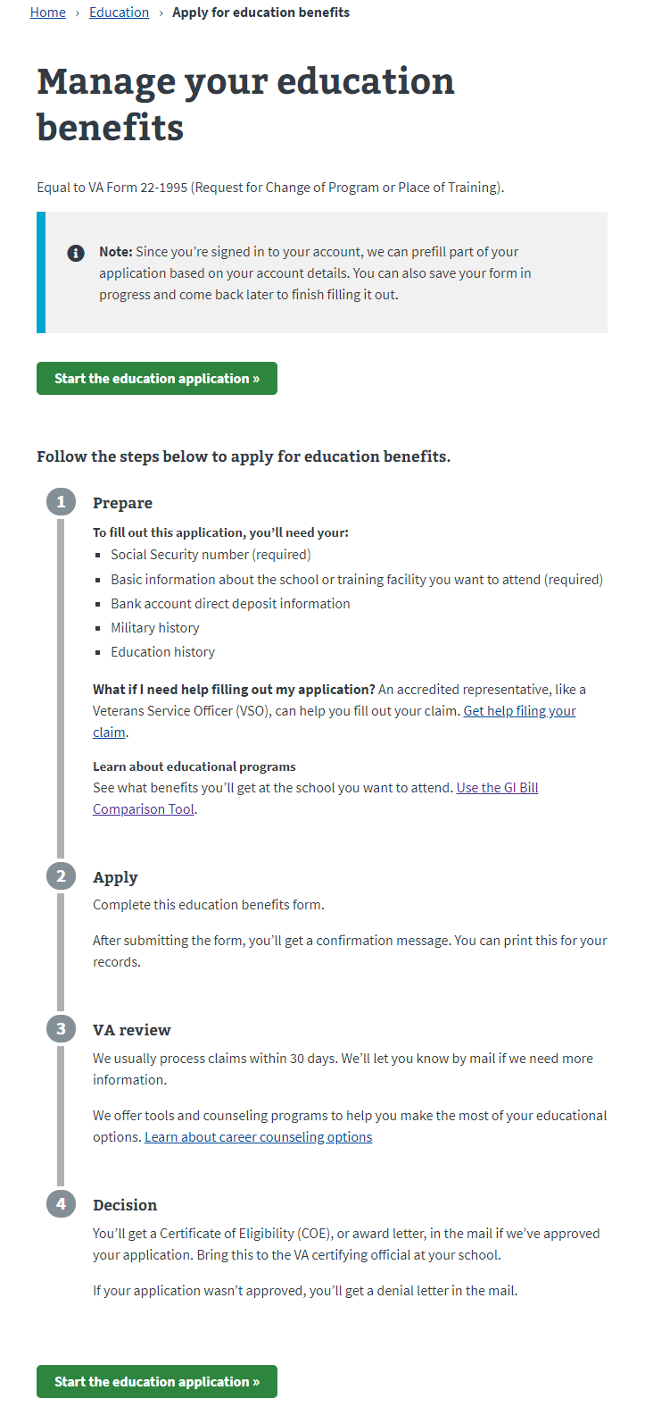

1. From the Applicant Information page, shown in Figure 3, enter or edit applicant information if needed and select **Continue**.

Figure 3: Applicant Information Page

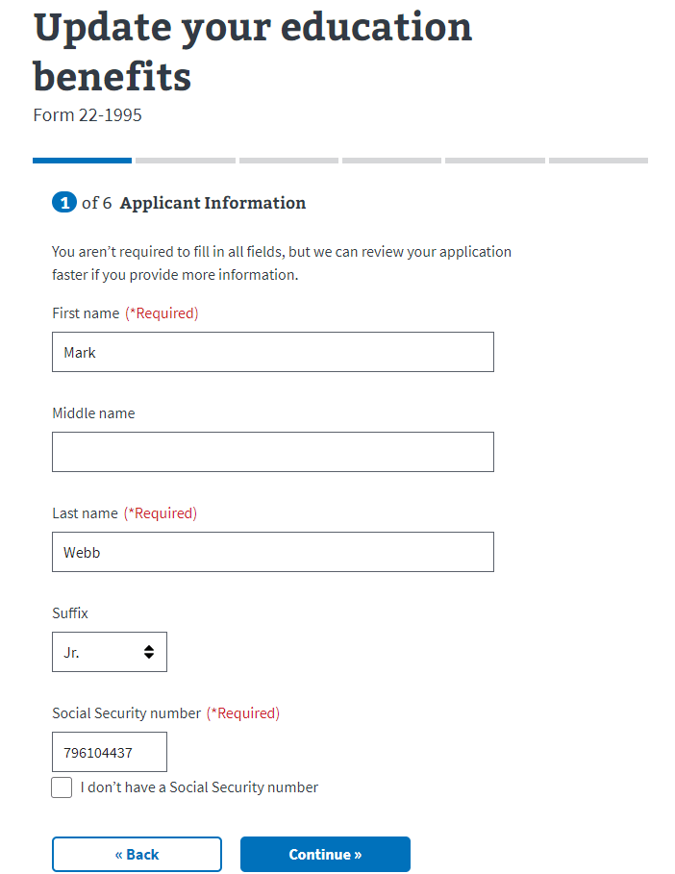

1. From the first Education Benefit page, shown in Figure 4, select a benefit. For more information, you can select the **Learn more** link for each benefit. If you select a non-Chapter 33 option, you may not be eligible for the Rogers STEM Scholarship.

Figure 4: Education Benefit Page – Select Benefit

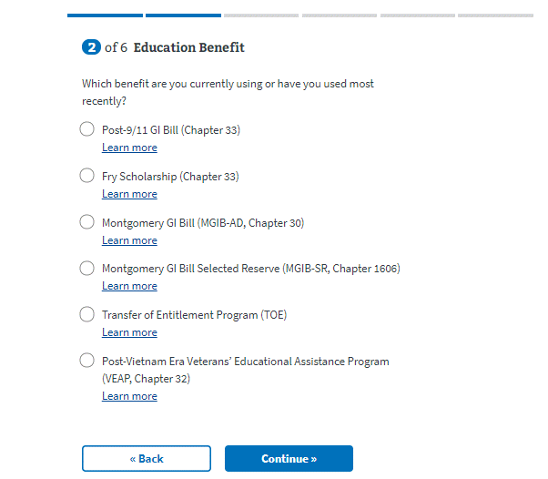

1. Select the **Continue** button.
2. From the second Education Benefit page, shown in Figure 5, review the eligibility requirements. You can select links to view Rogers STEM scholarship information, check your remaining benefits, or see approved STEM programs.

Figure 5: Education Benefit Page – Rogers STEM Scholarship

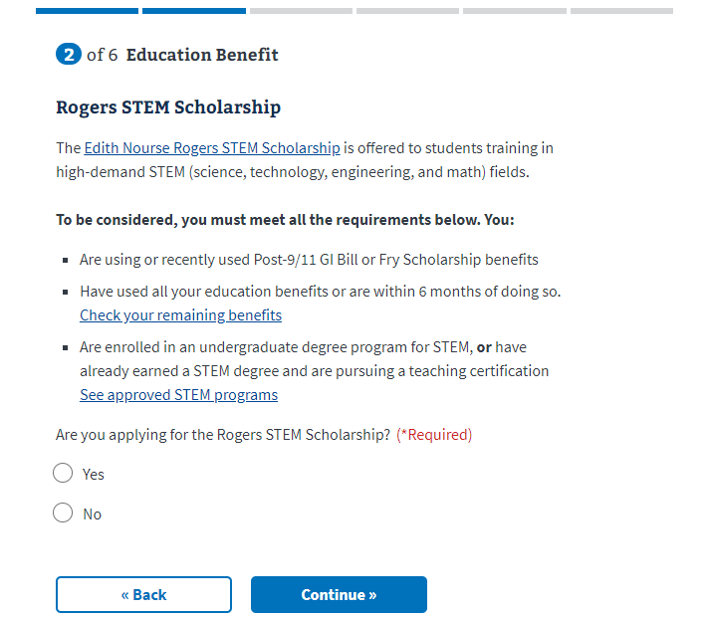

1. Select **Yes** for “Are you applying for the Rogers STEM Scholarship?”
2. Select **Yes** or **No** for “Are you enrolled in a science, technology, engineering, or math (STEM) undergraduate degree program?”.
3. If you select **No**, as shown in Figure 6, then select **Yes** or **No** for “Do you have a STEM undergraduate degree and are now pursuing a teaching certification?”

Figure 6: Education Benefit Page – Additional STEM Questions

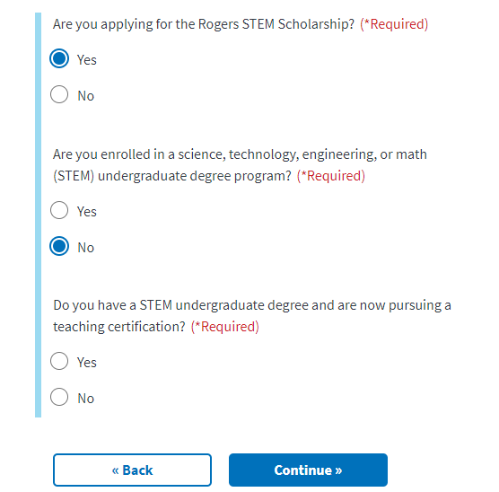

1. Select **Yes** or **No** for “Have you used all of your Post-9/11 GI Bill or Fry Scholarship benefits or do you have less than 6 months of benefits left?” as shown in Figure 7.

Figure 7: Education Benefit Page – Additional STEM Questions – Continued

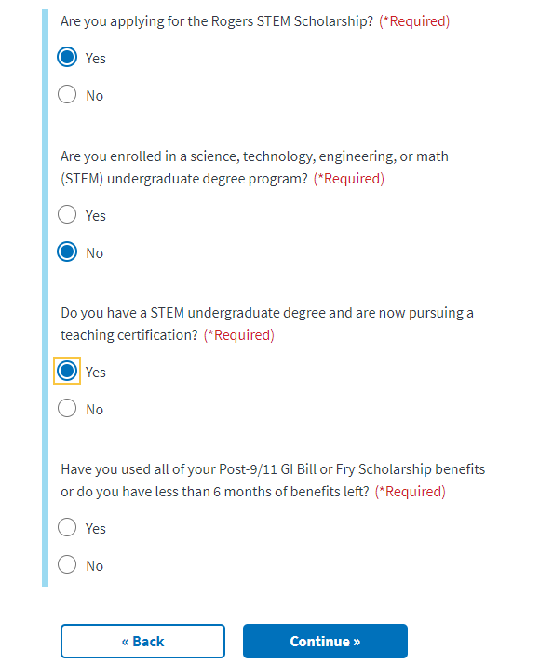

1. Select the **Continue** button.
2. Depending on your responses, the Rogers STEM Scholarship Eligibility page may open, as shown in Figure 8. You can select **Yes** and then select the **Continue** button to continue the application, although the page indicates that it appears you’re not eligible. You can also select **No** and select **Explore other education benefits** to exit.

Figure 8: Education Benefit Page –Rogers STEM Scholarship Eligibility

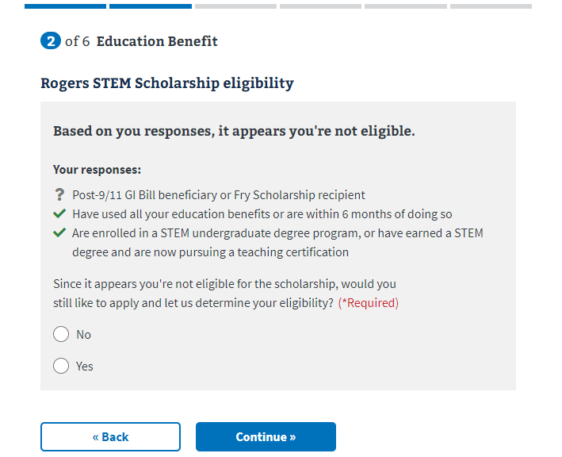

1. From the Military History page, shown in Figure 9, select **Yes** or **No** for “Are you currently on active duty or do you anticipate you will be going on active duty?” If you select **Yes**, a message regarding active duty is shown.

Figure 9: Military History Page

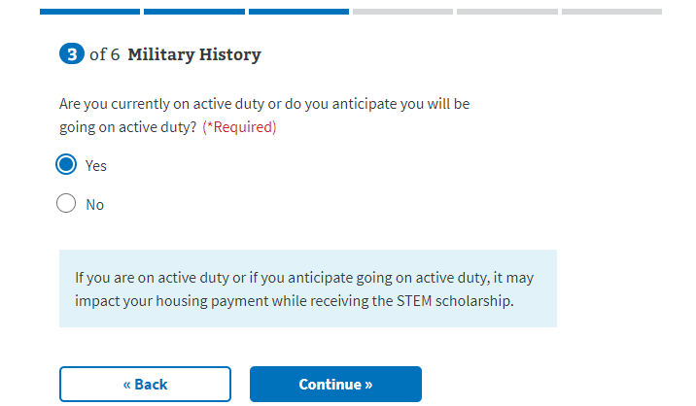

1. Select the **Continue** button.
2. From the first School Selection page, shown in Figure 10, enter information about the school, university, program, or training facility you want to attend.

Figure 10: School Selection Page – Want to Attend

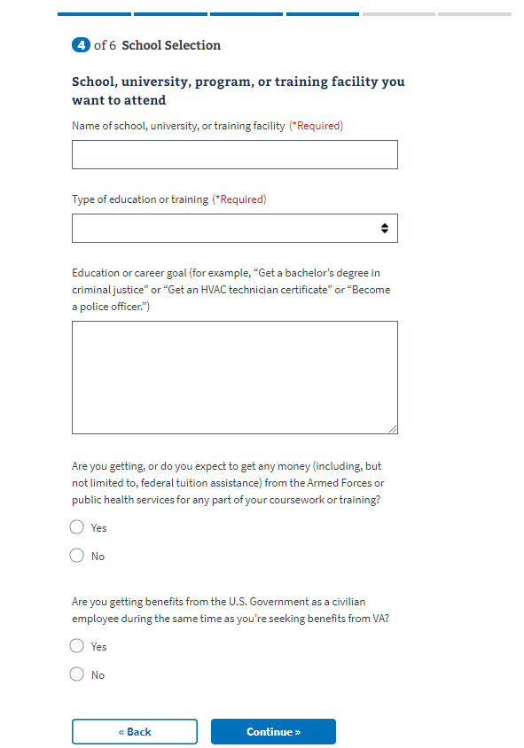

1. Select the **Continue** button.
2. From the second School Selection page, shown in Figure 11, enter information about the school, university, program, or training facility you last attended.

Figure 11: School Selection Page – Last Attended

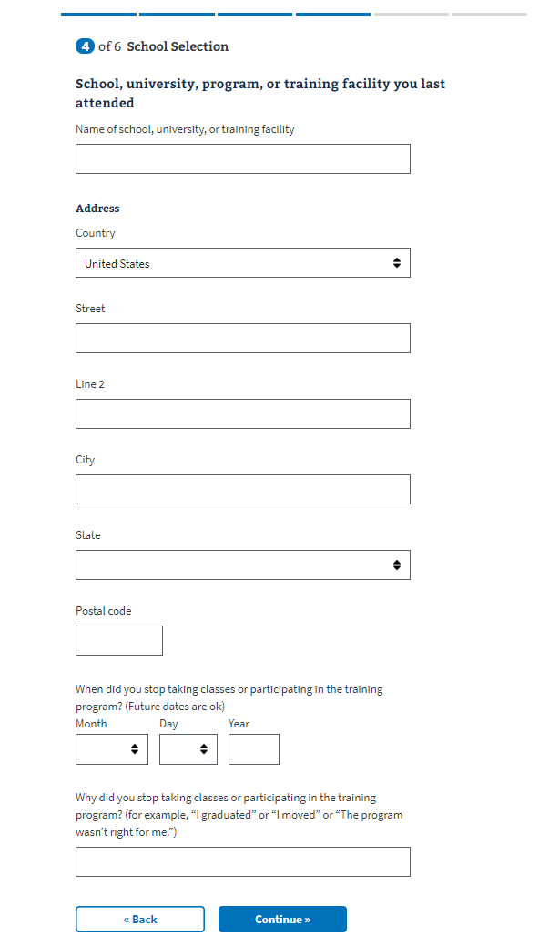

1. Select the **Continue** button.
2. From the first Personal Information page, shown in Figure 12, enter or edit contact information if needed and select the **Continue** button.

Figure 12: Personal Information Page – Contact Information

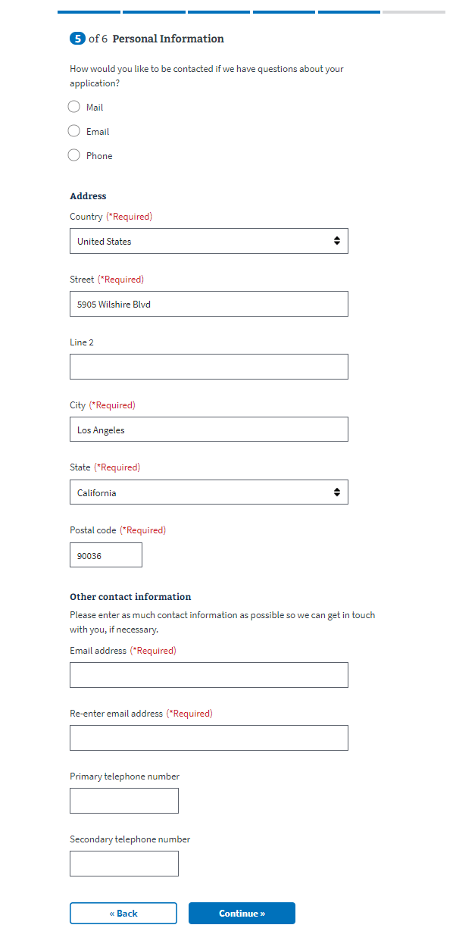

1. From the second Personal Information page, shown in Figure 13, select a **Benefit payment method** in the **Direct deposit** section.

Figure 13: Personal Information Page – Direct Deposit Options

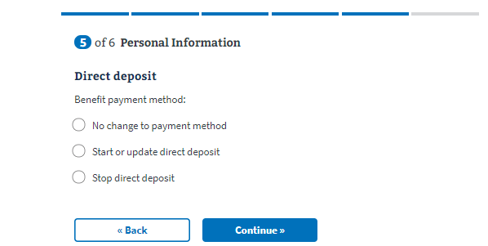

1. If you select **Start or update direct deposit**, as shown in Figure 14, enter account information.

Figure 14: Personal Information Page – Start or Update Direct Deposit

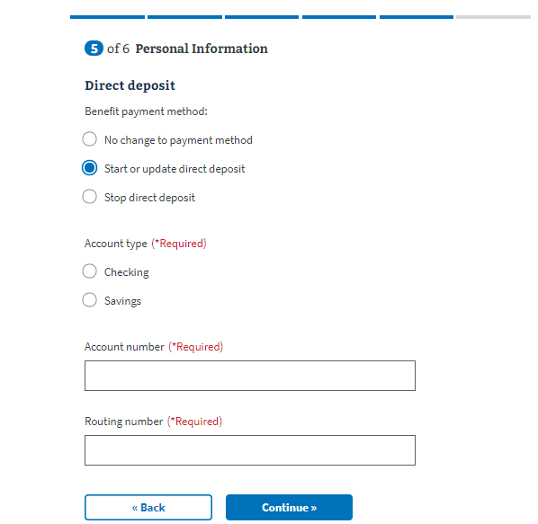

1. Select the **Continue** button.
2. From the **Review Application** page, shown in Figure 15, review your application information. The sections on this page are expandable. You can select **Edit** in any expanded section if additional editing is necessary.

Figure 15: Review Application Page

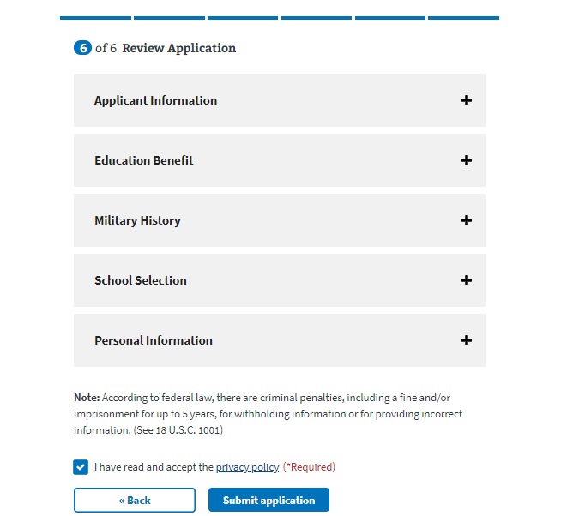

1. In the Education Benefit section, if you change your response to “Are you applying for the Edith Nourse Rogers STEM Scholarship?”, you must also edit your responses in the Military History section before submitting your application.
2. When you have finished reviewing your application information, select the **privacy policy** link to review the policy.
3. Select the check box to indicate you have read and accepted the privacy policy.
4. Select **Submit Application**.
5. Upon successful submission, the Claim Received page opens, shown in Figure 16. This page lists claim information including a Confirmation Number for tracking your application.

Figure 16: Claim Received Page

